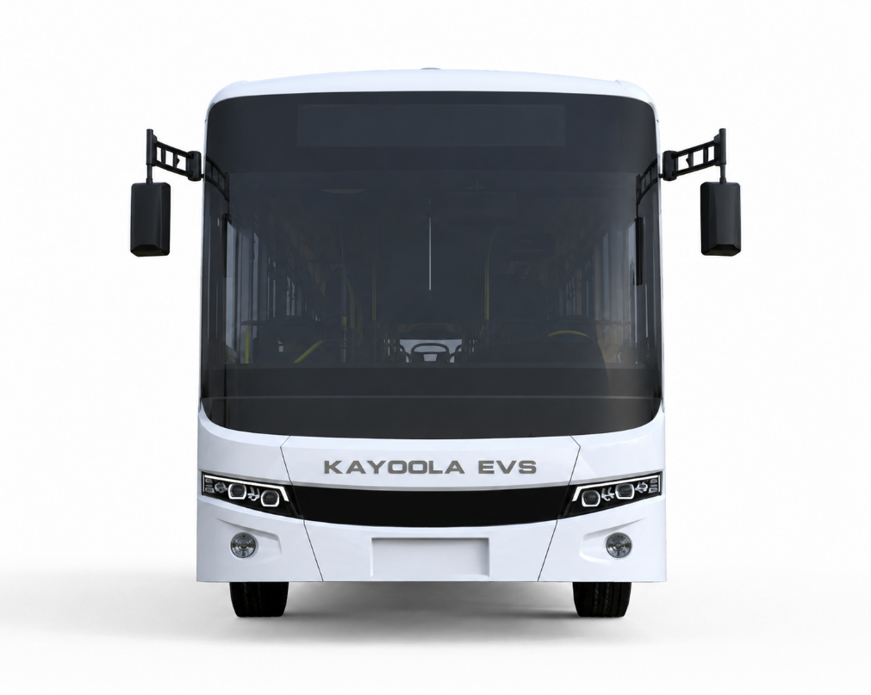
BUS PRODUCTION TRACKER
USER MANUAL
JUNE 2026

Confidentiality Statement:
The information contained in this document is property of the Kiira Motors Corporation. The information is supplied on the understanding that it will be held confidential and not disclosed, in whole or part, to third parties without the prior written consent of the Chief Executive Officer, Kiira Motors Corporation.
Tel: +256393517888 | Email: oceo@kiiramotors.com | Kiira Vehicle Plant, Plot No.701, Jinja Industrial and Business Park, Jinja-Kamuli Highway | Website: www.kiiramotors.com

Document Version History
 | Document Description | Bus Production Tracker User Manual
 | Reference No: | KMC.DPD.06/26-MN001
 | Prepared by: | Vehicle Integration
 | Document Owner: | Product Development
 | Issue Date: | 21.06.2026
 | Last Review Date:
Version no. | Next Review Date: | Reviewed By  (Name & Signature) | Approved By  (Name & signature)
01

TABLE OF CONTENTS
1 Introduction 7
1.1 How the system is structured 7
1.2 Where the data lives 7
2 User Roles and Access 7
2.1 Administrator versus standard user 8
2.2 What each role can do 8
3 Getting Started 8
3.1 Signing in 9
3.2 The Home screen 9
3.3 Light and dark mode 9
3.4 In-app help (the information guide) 9
3.5 Navigation and common controls 9
4 The Filter Bar 10
4.1 Available filters 10
4.2 Date ranges 11
4.3 Active filters and clearing 11
5 Line Tracker 11
5.1 Reading the map 11
5.2 Interacting 12
5.3 How a bus position is determined 12
6 Bus Report 12
6.1 Summary cards 12
6.2 Columns in each bus row 13
7 Dashboard 13
7.1 Top metric cards 14
7.2 Distribution charts 14
7.3 Performance highlights 14
7.4 Pareto and quality charts 14
7.5 Takt Time planning 14
7.6 Overrun root-cause insights 15
8 The Travel Card (Data Entry) 15
8.1 Step 1 - Identity 16
8.2 Step 2 - Activities 16
8.3 Production time: shift, breaks and net time 16
8.4 Step 3 - Overrun and root-cause capture 17
8.5 Step 4 - Sign-off 17
8.6 Step 5 - Done and PDF reports 17
8.7 Administrator only - editable clock-out 17
9 The Shared Catalog (Administrators) 17
9.1 What the catalog controls 18
9.2 Opening the catalog editor 18
9.3 The editor tabs 18
9.4 Archiving and legacy data 19
9.5 How edits reach everyone 19
10 Exporting and Reporting 19
10.1 Dashboard exports 20
10.2 Travel card PDFs 20
10.3 Scheduled email reporting 20
11 The Calculations Behind the System 22
11.1 Key terms 22
11.2 Gross, break and net production time (Travel Card) 22
11.3 Actual time and overrun (Travel Card) 22
11.4 Per-cause delay attribution (Travel Card) 22
11.5 Time at station and total time on floor (Bus Report) 22
11.6 Variance against the estimate (Bus Report) 23
11.7 Schedule status (Bus Report) 23
11.8 Progress along the line (Bus Report) 23
11.9 Average dwell time per station (Dashboard) 23
11.10 Station efficiency and variance (Dashboard) 23
11.11 Line performance (Dashboard) 23
11.12 Production rate (Dashboard) 23
11.13 Takt time and output gap (Dashboard) 23
11.14 Weekly production trend (Dashboard) 24
11.15 First Pass Yield (Dashboard) 24
11.16 Overrun analytics (Dashboard) 24
11.17 Downtime Pareto (Dashboard) 24
11.18 Rework hours by station (Dashboard) 24
11.19 The 6M root-cause framework 24
12 Data, Refresh and Troubleshooting 25
12.1 Refresh intervals 25
12.2 Common situations 25

LIST OF FIGURES
Figure 2.1 User Login Page 8
Figure 3.1 Home Screen 9
Figure 3.1 Light Toggle and Sign out Buttons 9
Figure 4.1 The Filter Bar 10
Figure 5.1 Line Tracker 12
Figure 6.1 Bus Report 13
Figure 7.1 Dashboard 14
Figure 8.1 The Travel Card (Data Entry) 16
Figure 9.1 The Shared Catalog (Administrators) 18
Figure 10.1 Exporting and Reporting 20

Introduction
The Bus Production Tracker is a web-based system used to monitor the assembly of buses across the Kiira Motors Corporation (KMC) production plant in real time, to capture production data at every station, and to turn that data into performance, quality and downtime analytics. It supports two bus families: KDC (diesel; 10.5 m and 12 m) and EVS (electric; 7 m, 8.5 m, 10.5 m and 12 m). A third family, KEC, is listed but its templates are not yet available.

How the system is structured
The application has two halves that share the same data:
- The Travel Card - the form operators and reviewers complete each time a bus passes through a station. This is how data gets in.
- The Tracker (Line Tracker, Bus Report, Dashboard) - the read-only views that turn captured data into a live picture of the floor and management analytics.

Where the data lives
There is no traditional back-end server; all data flows through one Google Sheet ("NI Travel Tool Data"):
- Submitted travel cards are sent to a Google Apps Script web app, which writes each station move to the "Travel Card Data" tab and related tabs (submissions, overruns, overrun causes, activities, etc.).
- The Tracker reads the data tabs (as CSV) and refreshes automatically - production data every 60 seconds, station times every 5 minutes, the overruns data every 5 minutes, and the catalog every 2 minutes.
- The shared catalog is stored in a "Catalog" tab as a single JSON document, written back through the same Apps Script (protected by an admin token).

User Roles and Access
Version 2.0 introduces two roles. Your role is decided by the credentials you sign in with and is remembered on your device.
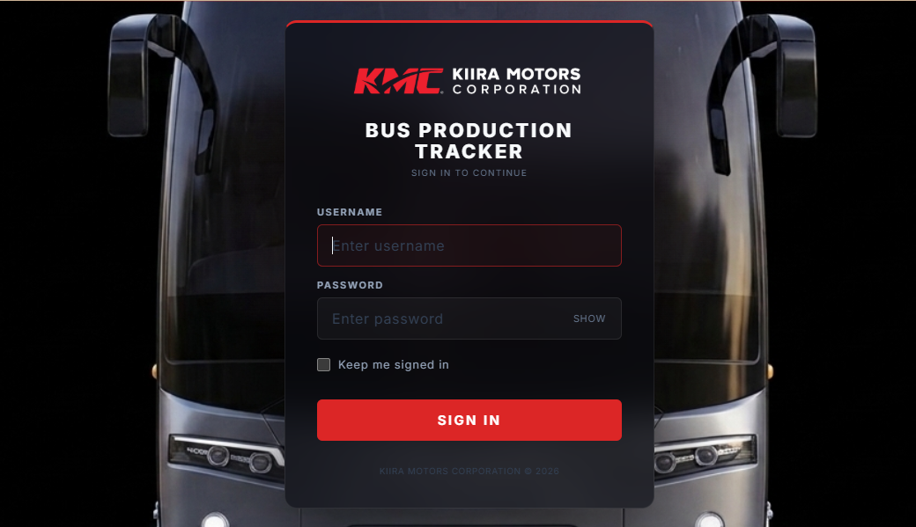
Figure 2.1 User Login Page

Administrator versus standard user
Role | Signs in as | Intended for
Administrator | the admin username (e.g. kmcadmin) | Supervisors who maintain the catalog and correct records.
Standard user | the standard username (e.g. kmc) | Operators and reviewers logging day-to-day production.
Note: Treat credentials as confidential and obtain them from your supervisor. Because the application is a static front-end over a shared sheet, role control governs what the interface offers; it is not a substitute for sheet-level permissions.

What each role can do
Capability | Standard user | Administrator
Log travel cards, view all Tracker views | Yes | Yes
Edit the shared catalog (projects, lines, stations, activities, resources) | No | Yes
Edit the clock-out time on a travel card | No (auto-recorded) | Yes
Export reports, schedule email reports, use in-app help | Yes | Yes

Getting Started

Signing in
- Enter your username (not case-sensitive).
- Enter your password (case-sensitive). Use SHOW/HIDE to reveal it.
- Optionally tick "Keep me signed in" to skip the login screen next time on this device.
- Press Sign In. The system remembers whether you signed in as an administrator or a standard user.

The Home screen
After signing in you can choose Travel Card (to log a bus at a station) or Tracker (the live monitoring views).
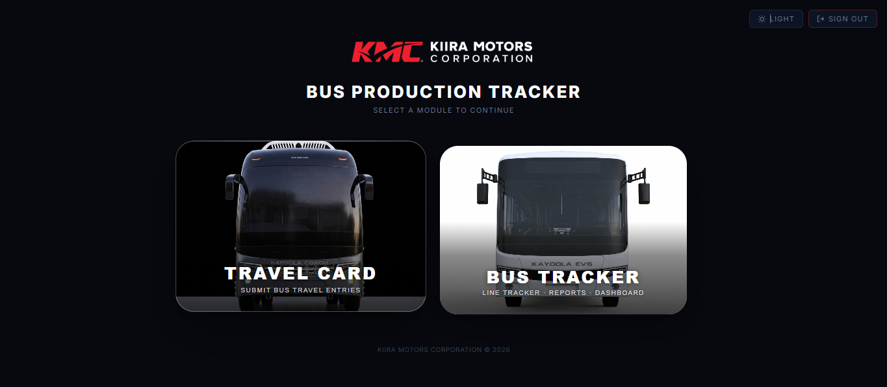
Figure 3.1 Home Screen

Light and dark mode
A sun/moon toggle on the login, Home and main screens switches the colour theme. Your choice is remembered.
Figure 3.2 Light Toggle and Sign out Buttons

In-app help (the information guide)
Each module has an information (ⓘ) button that opens a short feature guide for that module - one for the Travel Card and one for the Tracker. It lists the main features in plain language and is the quickest reminder while working.

Navigation and common controls
Control | What it does
Home | Return to the Home screen.
Line Tracker / Bus Report / Dashboard | Switch between the three monitoring views.
Sync indicator | A pulsing dot with the last-updated time, or a spinner while loading.
Estimates badge | How many station designed-time estimates have loaded.
ⓘ Info | Open the in-app feature guide for the current module.
Edit Catalog | Administrators only - open the catalog editor.
Refresh | Immediately re-fetch the latest data.
Light / Dark | Toggle the colour theme.
Sign Out | Log out (also clears the remembered role).
On phones and tablets the navigation collapses into a hamburger (menu) button containing the same options.

The Filter Bar
A single filter bar sits at the top of all three Tracker views. Whatever you set is applied to the Line Tracker, Bus Report and Dashboard at the same time, so the whole application reflects the same slice of data.
Figure 4.1 The Filter Bar

Available filters
Filter | Options | Effect
Model | All / KDC / EVS | Limits to one bus family (by whether the model name contains KDC or EVS).
Project | All Projects or a specific project | Limits to buses on one project.
Date | All Time, Today, Yesterday, 7 Days, 30 Days, Custom | Limits records to a date window.
Line | All Lines or one line | Shows only buses currently on the chosen line.
Station | All Stations or one (enabled once a line is chosen) | Shows only buses at the chosen station.
Status | All, Approved, Pending, OHS Issue, Overrun, Rework | Filters buses by their latest recorded condition.

Date ranges
- Today / Yesterday - that single calendar day.
- 7 Days - today plus the previous six days.
- 30 Days - today plus the previous 29 days.
- Custom - choose your own From and To dates; the bar shows the inclusive number of days.
A record is included when its timestamp falls between the start of the start date (00:00:00) and the end of the end date (23:59:59).

Active filters and clearing
Each active filter appears as a removable chip, and a running bus count (filtered of total) is shown. Press Clear to reset everything at once.

Line Tracker
The Line Tracker is the visual map of the floor. Each production line is a card containing a horizontal rail of station dots in process order, and each bus is shown as a small card above the station it currently occupies.
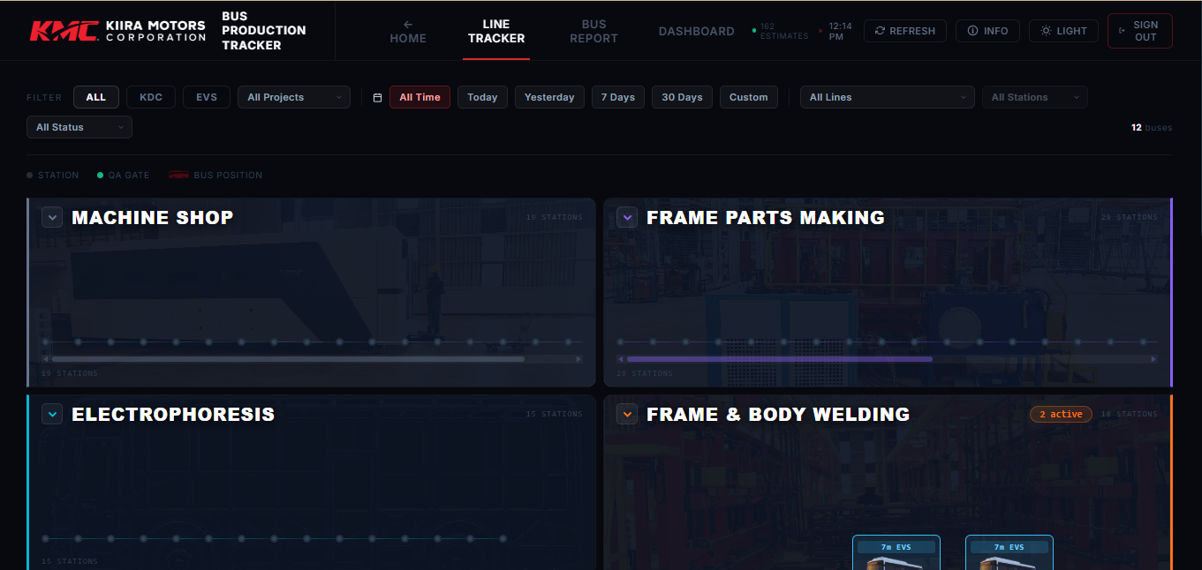
Figure 5.1 Line Tracker

Reading the map
Element | Meaning
Grey dot | An ordinary station with no bus on it.
Green (larger) dot | A Quality Gate / inspection station.
Red dot | A station that currently has one or more buses.
Bus callout | A card with the model badge, a model image and the VIN - red for KDC, blue for EVS.
"N active" badge | On a line header - the number of buses on that line.

Interacting
- Hover or tap a station dot for its code, full name and bus count.
- Hover a bus callout for its model, VIN, station and last-move time.
- Click a line header to collapse or expand it; each rail scrolls horizontally.

How a bus position is determined
A bus has one record per station it has visited. The map shows each bus once, at its latest position, by grouping records by VIN and keeping the most recent timestamp. Only buses whose station code is recognised in the catalog/station database are shown. Model and project filters hide stations and lines that do not apply.

Bus Report
The Bus Report is a per-bus table, sorted with the longest-resident buses first - the best view for spotting buses that are stuck or behind.
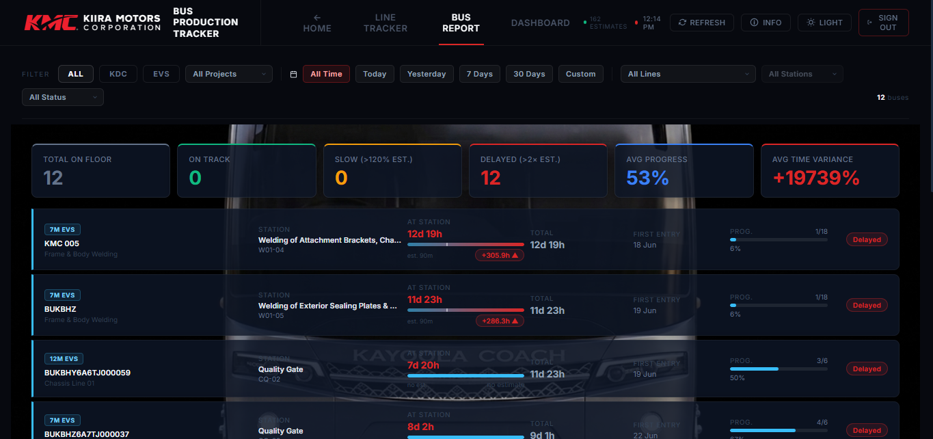
Figure 6.1 Bus Report

Summary cards
Card | Meaning
Total on floor | Number of buses shown.
On Track | Buses within 120% of their station estimate.
Slow (>120% est.) | Buses between 120% and 200% of estimate.
Delayed (>2x est.) | Buses over 200% of estimate.
Avg progress | Average completion percentage across the buses shown.
Avg time variance | Average percentage difference of actual vs estimated time.
Pending / Rejected / OHS | Shown only when buses are in those conditions.

Columns in each bus row
Column | What it shows
VIN + Model | Identifier, model badge and line.
Station | Current station name and code.
At Station | Time at the current station, a bar versus the estimate, and a variance pill.
Total | Total time on the floor since the first record.
First Entry | Date the bus first appeared.
Prog. | Stations visited of stations on the line, as a percentage.
Badges | Status, approval status and an OHS warning if applicable.
Note: The variance pill is colour-coded: green on or under the estimate (up to 20% over), amber up to 100% over, red beyond. Hover it for the exact estimated and actual minutes.

Dashboard
The Dashboard aggregates the data into management metrics and charts, honouring the filter bar.
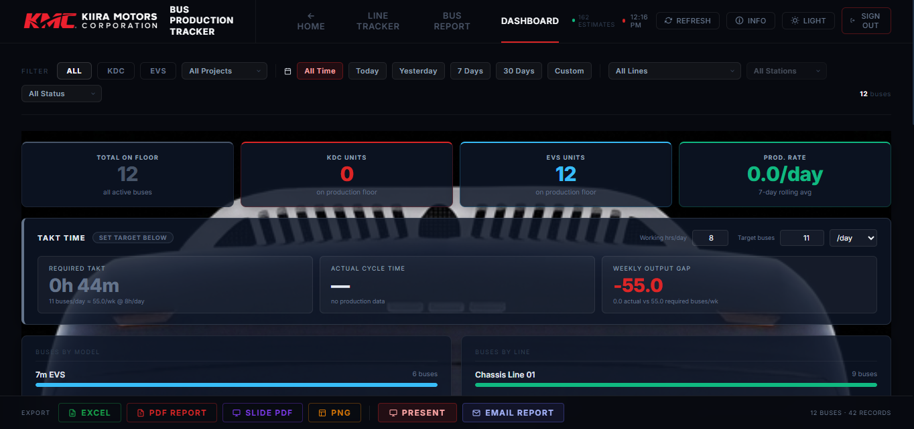
Figure 7.1 Dashboard

Top metric cards
Metric | Meaning
Total on floor | All active buses in the current filter.
KDC units / EVS units | Active buses of each family.
Prod. rate | 7-day rolling average of buses reaching Quality (QA) per day.
First Pass Yield | Percentage of completed buses needing no rework (shown when rework data exists).

Distribution charts
- Buses by model - how many buses of each model are on the floor.
- Buses by line - where the buses currently are.

Performance highlights
Four cards name the best and slowest station and line. With estimates they rank by variance against estimate; otherwise by average dwell time. Each shows an efficiency percentage.
Note: Station and line performance focus on the plant's major (milestone) stations, so the rankings are not skewed by very short sub-stations.

Pareto and quality charts
- Overrun by Station - top stations by total overrun minutes, with counts and averages.
- Downtime by Reason - Pareto of downtime minutes by reason, with cumulative percentages.
- Rework Hours by Station - stations ranked by total rework hours.
- Station Efficiency - planned divided by actual time per station, banded green (≥95%), amber (80–94%) and red (<80% bottleneck).
- Weekly Production Trend - buses reaching QA each week over the last 12 weeks.
Note: Quality, downtime and rework charts appear only once the underlying data exists; otherwise they are hidden automatically.

Takt Time planning
The Takt Time panel turns a production target into the pace the line must run at, and compares it to the actual pace. Enter two figures:
- Shift hours per day - the productive hours available each working day.
- Production target - the number of buses required, per day, week, month or year.
From these it shows four indicators:
Indicator | Meaning
Required Takt | The time that should be spent per bus to hit the target (the required pace).
Actual Cycle Time | The current time per bus, from the 7-day production rate and the shift length.
Takt Ratio | Actual cycle time as a percentage of required takt, with an AHEAD / ON TAKT / BEHIND status.
Weekly Output Gap | Buses per week ahead of (positive) or short of (negative) the target.
A gauge marks the required-takt target so you can see at a glance whether the line is ahead of or behind takt. Your shift, target and period settings are remembered on the device. The exact formulas are in Section 11.

Overrun root-cause insights
Drawing on the dedicated overruns data, this section breaks overruns down well beyond simple station totals. It appears once the overruns data holds at least one record, and comprises four panels:
- Overrun by Root Cause - 6M analysis - a Pareto of the six categories (Man, Machine, Method, Material, Measurement, Mother Nature) by total overrun minutes, with drill-down to the specific sub-cause under each.
- Overrun by Project - total and average overrun minutes for each project.
- Designed vs Actual Time by Station - the top overrunning stations, with twin bars comparing planned and actual minutes and a variance percentage.
- Corrective Action Log - the largest overruns together with the corrective actions and comments recorded on their travel cards.

The Travel Card (Data Entry)
The Travel Card logs a bus at a station and is the single source of all data. It is a five-step wizard - Identity, Activities, Overrun, Sign-off, Done - shown by the progress bar. The Overrun step appears only when a station takes longer than its designed time. The card serves both KDC and EVS; only the lines, stations, activities and resources valid for the chosen model are offered.
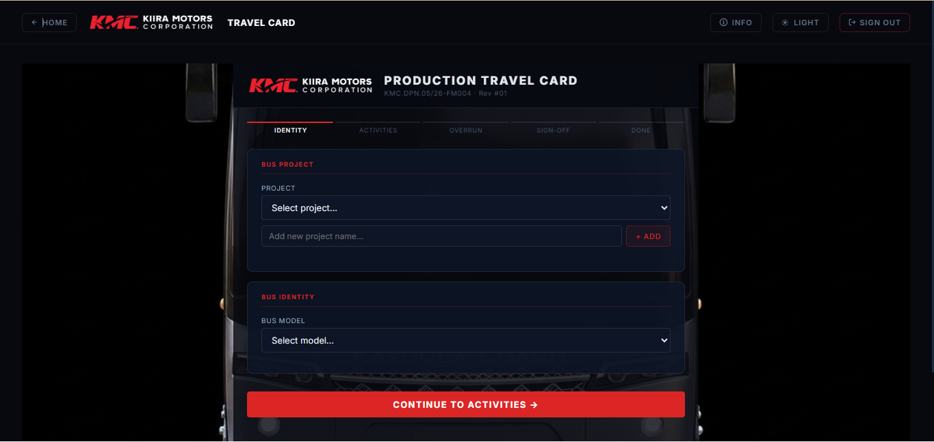
Figure 8.1 The Travel Card (Data Entry)

Step 1 - Identity
- Bus project - select an existing project or add a new one (projects come from the shared catalog).
- Bus model - choose the model (KDC or EVS; KEC is shown but inactive).
- Bus VIN - select or add the VIN for the project.
- Production line and Station - choose where the bus is.
- Designed (cycle) time - loaded automatically from the Station Times sheet; can be entered manually if missing.
- Staff on duty - tick the operators present (remembered per station) and record the HSE resources required.
Note: When you leave the Identity step, the clock-out time is captured automatically as the current time, and is used with your clock-in to compute the time used at the station.

Step 2 - Activities
- Clock in - enter the time work started at this station.
- Activities - set each predefined activity to Complete, Issue noted, Rework needed or N/A. "All Complete" and "Clear" shortcuts are available.
- Consumables & Materials Used - record quantities for preset consumables, remove any not used, and add others. Quantities are remembered per station.
- Health, Safety & Environment - flag any OHS issue (with a description) and note any waste generated.

Production time: shift, breaks and net time
Time used at a station is calculated from clock-in to clock-out but excludes scheduled non-productive breaks. The default schedule is a shift of 08:00–18:00 with a tea break (10:00–10:30) and lunch (13:00–14:00). The card reports both the gross elapsed time and the net productive time after removing any break overlap; the net figure is what is compared against the designed time to detect an overrun. The exact formulas are in Section 11.

Step 3 - Overrun and root-cause capture
If the net time exceeds the designed time, the form diverts to the Overrun step. It shows the designed, actual (net) and overrun minutes, and notes how many break minutes were excluded. You then identify the cause(s):
- Select one or more of the 6M categories (Man, Machine, Method, Material, Measurement, Mother Nature), each with a specific sub-cause.
- Add custom causes beyond the 6M set where needed.
- Enter a delay in minutes against each selected cause; the form totals the delay attributed.
- Record the immediate corrective action taken and any comments.
If there is no overrun this step is skipped. The causes, per-cause delays, corrective action and comments are stored on the overruns data and feed the Dashboard's Overrun Root-Cause Insights.

Step 4 - Sign-off
- Reviewer name - choose a saved reviewer or type a new one (which can be saved).
- Approval status - Approved, Pending review, or Rejected / Rework required.
- Review date and any comments, then press Submit travel card.

Step 5 - Done and PDF reports
On submission the record is saved to Google Sheets (with a local copy kept on the device). The confirmation page summarises the station (including break minutes excluded and any overrun) and offers two PDF downloads:
- Station report - this single submission, including a per-cause overrun breakdown listing each cause and its delay plus the total delay attributed.
- Full bus report - the complete history logged for that VIN on this device.
Submitting a card automatically refreshes the live dashboard. The card can also be opened pre-filled from a bus in the Tracker.

Administrator only - editable clock-out
Standard users keep the automatically recorded clock-out time. Administrators see an editable clock-out (and clock-in) field, so a mistimed record can be corrected before submission. The net production time is recalculated from the corrected values.

The Shared Catalog (Administrators)
The catalog is the single source of truth for projects, lines, stations, activities and resources. Editing it once updates both the Travel Card dropdowns and the Tracker map for everyone. Only administrators can edit it.
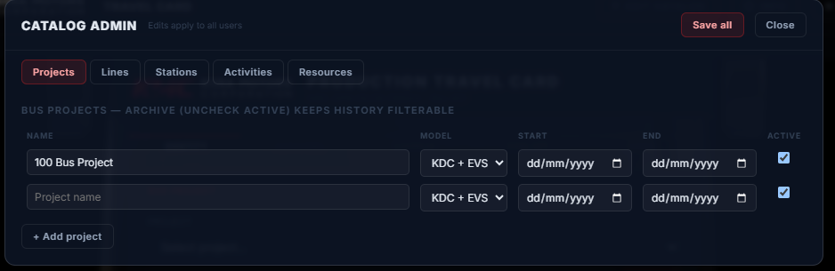
Figure 9.1 The Shared Catalog (Administrators)

What the catalog controls
- Projects - names, models and active/effective dates.
- Lines and stations shown on the Tracker map.
- The lines and stations offered on the Travel Card, and which model each applies to.
- The predefined activities and consumables/resources for each station.

Opening the catalog editor
Sign in as an administrator and press the Edit Catalog button (available from both the Travel Card and the Tracker). The editor opens as a modal with five tabs.

The editor tabs

Projects
Add, rename or archive projects and set the model and effective dates. Projects feed the Travel Card project list and the Tracker project filter.

Lines
Define the production lines, their labels and which models they apply to.

Stations
Add or edit stations (code, name, line, order, models). Stations can be archived, tagged to specific projects, and given effective-from / effective-to dates so historical lines remain meaningful.

Activities
Maintain the list of predefined activities for each station.

Resources
Maintain the preset consumables and materials for each station, grouped by line.

Archiving and legacy data
Removing an item archives it (marks it inactive) rather than deleting it. Archived stations are still resolved when displaying older buses, so historical records are never hidden or broken. Archived stations are hidden from the live map unless a project filter that matches them is applied.

How edits reach everyone
Saving writes the whole catalog back to the Catalog tab of the Google Sheet (through the Apps Script, protected by an admin token). Other users pick up the change at the next catalog refresh (about every two minutes) or when they reload. Each surface keeps its built-in data as a seed and merges the catalog over it, so the app keeps working even if the catalog is empty or briefly unavailable.

Exporting and Reporting
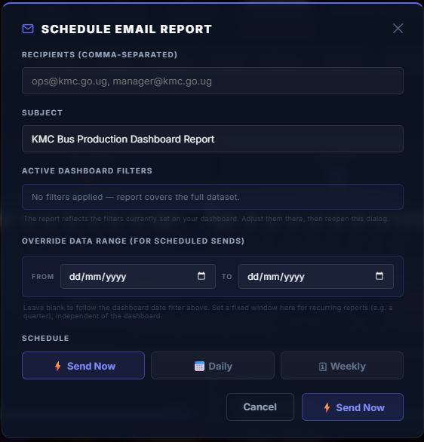
Figure 10.1 Exporting and Reporting

Dashboard exports
A fixed export bar at the bottom of the Dashboard shares the current (filtered) view:
Export | What you get
Excel | A multi-sheet .xlsx workbook (Summary, Buses, Efficiency, Downtime, Rework, History).
PDF Report | A formatted, KMC-branded white PDF report.
Slide PDF | A dark presentation-style PDF (cover, analytics and bus report).
PNG | The cover slide as a single image.
Present | Full-screen presentation / slide-deck mode.
Email Report | Open the Schedule Email Report dialog (see below).

Travel card PDFs
From the Done step of a travel card you can download a single-station report (including the per-cause overrun breakdown) or a full bus report covering that VIN's logged history on the device.

Scheduled email reporting
The Email Report button opens the Schedule Email Report dialog, which sends the dashboard report - slides, PDFs and the Excel workbook - to one or more recipients, either immediately or on a recurring schedule.

Setting up a report
- Recipients - one or more email addresses, separated by commas.
- Subject - editable; defaults to "KMC Bus Production Dashboard Report".
- Confirm the active dashboard filters - these are shown read-only so you can see exactly what the report will cover. To change them, adjust the filters on the dashboard and reopen the dialog.
- Optionally set a Report Data Range (From / To) - an independent date window applied to the attached data, separate from the dashboard's own date filter.
- Choose a schedule: Send Now, Daily, or Weekly.
- For Daily or Weekly, set the send time (and, for Weekly, the day of the week).
- Press the action button to send now or save the schedule.

What gets attached
The report files are generated automatically and attached to the email:
Attachment | Contents
KMC_CoverSlide_[date].png | Dashboard cover slide (dark theme).
KMC_Presentation_[date].pdf | Dark slide PDF - cover, analytics and bus report.
KMC_Dashboard_[date].pdf | Branded white PDF report.
KMC_Dashboard_[date].xlsx | Excel workbook (Summary, Buses, Efficiency, Downtime, Rework, History).

Managing saved schedules
Daily and weekly schedules are listed in an Active Schedules panel showing each recipient list, the timing, any data range and the filters in force. You can cancel an individual schedule or cancel them all.
Note: Delivery depends on the email server. When an email-server endpoint is configured, reports are sent automatically (immediately, or at the saved daily/weekly time). When no server is configured, the dialog falls back to opening your mail client with a pre-filled summary, and you attach the generated files manually if your client does not include them.

The Calculations Behind the System
This section explains, in plain terms, every calculation the system performs. All time data ultimately comes from travel-card timestamps and from the designed (planned) cycle times held in the Station Times sheet.

Key terms
Term | Definition
Record / move | One travel-card row: a bus (VIN) at a station at a timestamp.
Latest position | For each VIN, the record with the most recent timestamp.
Designed time | The planned cycle time for a station, in minutes.
Gross time | On a card, elapsed clock-out minus clock-in.
Net (actual) time | Gross time minus scheduled break overlap - the figure compared to designed time.
Dwell time | Time between a bus arriving at one station and moving to the next.

Gross, break and net production time (Travel Card)
Gross time is the raw elapsed time at the station:
Gross (min) = ( Clock-out − Clock-in ) ÷ 60,000 ms
The system then totals any scheduled break time that overlaps the worked span (tea 10:00–10:30 and lunch 13:00–14:00), across every day the span covers, and removes it:
Net (min) = Gross − Overlapping break minutes (never below 0)
Net time is what the rest of the system treats as the actual time at the station.

Actual time and overrun (Travel Card)
An overrun occurs when net time exceeds the designed time:
Overrun (min) = Net − Designed (only when Net > Designed)
An overrun forces a root-cause analysis before the card can be signed off.

Per-cause delay attribution (Travel Card)
Each selected cause (6M or custom) can be given its own delay in minutes. The form sums them so the lost time can be apportioned:
Total delay attributed = sum of each cause's delay minutes
These per-cause delays are stored with the submission and feed the Dashboard's Overrun Root-Cause Insights.

Time at station and total time on floor (Bus Report)
Time at station = Now − timestamp of latest record
Total on floor = Now − timestamp of first record
Both are shown in a friendly format (for example 2d 6h, 5h, or 40m).

Variance against the estimate (Bus Report)
Variance % = ( Actual minutes − Designed minutes ) ÷ Designed minutes × 100
Positive means over plan, negative means under. Calculated only for stations with a designed time.

Schedule status (Bus Report)
Ratio = Time at station ÷ Designed time
Status | With estimate | Without estimate
On Track | Ratio ≤ 1.2 | At station ≤ 24 hours
Slow | Ratio 1.2 to 2.0 | At station 24–48 hours
Delayed | Ratio > 2.0 | At station over 48 hours

Progress along the line (Bus Report)
Progress % = ( Distinct stations visited ÷ Stations on the line ) × 100 (capped at 100%)

Average dwell time per station (Dashboard)
Walking each bus's sorted history, the gap between consecutive moves is measured:
Dwell (hours) = ( time at next station − time at this station ) ÷ 3,600,000 ms
Only gaps greater than 0 and less than 72 hours are counted, to exclude errors and idle weekends. Then:
Average dwell = Total dwell hours ÷ Number of moves counted

Station efficiency and variance (Dashboard)
Variance % = ( Actual hours − Estimated hours ) ÷ Estimated hours × 100
Efficiency % = ( Estimated hours ÷ Actual hours ) × 100
100% means exactly on plan; above is faster, below is slower. Bands: green ≥95%, amber 80–94%, red <80% (bottleneck). These are computed over the plant's major stations.

Line performance (Dashboard)
Line average dwell = mean of its stations' average dwell
Line variance % = mean of its stations' variance %
Line efficiency % = 100 ÷ ( 1 + Variance% ÷ 100 )

Production rate (Dashboard)
Prod. rate = Distinct buses reaching QA in last 7 days ÷ 7

Takt time and output gap (Dashboard)
The Takt Time panel converts your production target into a required pace and compares it with the actual pace. First the target is expressed per week (assuming five working days):
Target/week = Target × ( 5 if /day · 1 if /week · ÷4.33 if /month · ÷52 if /year )
Then:
Required Takt (h/bus) = ( Shift hours/day × 5 ) ÷ Target per week
Actual Cycle Time (h/bus) = Shift hours/day ÷ Production rate (buses/day)
Takt Ratio = Actual Cycle Time ÷ Required Takt
Weekly Output Gap = ( Production rate × 5 ) − Target per week
The status is Ahead of takt when the ratio is 0.95 or below, On takt between 0.96 and 1.05, and Behind takt above 1.05.

Weekly production trend (Dashboard)
Each bus's first QA arrival is grouped by ISO calendar week for the last 12 weeks. The average shown is:
Weekly average = Total buses reaching QA ÷ Number of weeks with activity

First Pass Yield (Dashboard)
FPY % = ( Completed buses − Buses needing rework ) ÷ Completed buses × 100
"Completed" means at least one QA record; a bus counts against FPY if any of its records is flagged for rework. Bands: green ≥90%, amber 75–89%, red <75%.

Overrun analytics (Dashboard)
Overrun minutes are summed per station; each station reports total, occurrences and average:
Average overrun = Total overrun minutes ÷ Number of overrun cards
Using the dedicated overruns data, overruns are also aggregated by 6M root cause (and sub-cause), by project, and by station with a designed-versus-actual variance:
Station variance % = ( Total actual − Total designed ) ÷ Total designed × 100

Downtime Pareto (Dashboard)
Reason share % = Reason downtime ÷ Total downtime × 100
Cumulative % = running total of reason shares (capped at 100%)
Reasons are ranked largest first - the classic Pareto ordering for finding the vital few causes.

Rework hours by station (Dashboard)
Rework hours from cards flagged for rework are summed per station and ranked highest to lowest.

The 6M root-cause framework
Category | Covers
Man | Operator skill, fatigue, attendance, method, communication.
Machine | Equipment breakdown, tooling, fixtures, calibration, setup delay.
Method | Process sequence, work instructions, procedures, design issues.
Material | Shortages, wrong or defective parts, consumables, handling delays.
Measurement | Gauge/instrument error, inspection delays, tolerance and documentation.
Mother Nature | Environment - temperature, humidity, power, ventilation, vibration.
Version 2.0 also allows custom causes beyond these six, each with its own attributed delay.

Data, Refresh and Troubleshooting

Refresh intervals
Data | Source | Auto-refresh
Travel card / production data | Travel Card Data tab (CSV) | Every 60 seconds
Station designed times | Station Times sheet (CSV) | Every 5 minutes
Overrun root-cause data | Overruns tab (CSV) | Every 5 minutes
Shared catalog | Catalog tab (CSV) | Every 2 minutes
Press Refresh to fetch immediately rather than waiting for the next cycle.

Common situations
You see… | Meaning / action
"Could not load data from Google Sheets" | The sheet could not be reached. Check the connection and that the sheet is still shared, then press Refresh.
A bus is missing from the map | Its station code may not be in the catalog, or it is filtered out. Check active filters and the station code.
"No buses on floor" | No records match the current filters. Widen the date range or press Clear.
Rankings show dwell instead of variance | Station estimates have not loaded yet; they switch to variance once the Station Times sheet arrives.
Overrun root-cause insights are absent | The overruns data has no records yet; the panels appear once at least one overrun is logged.
Email opens your mail client instead of sending | No email server is configured, so the dialog falls back to a mail-client draft; attach the downloaded files manually.
"Station time exceeded" on a card | Net time beat the designed time - complete the root-cause analysis to continue.
No Edit Catalog button | You are signed in as a standard user. Sign in as an administrator to edit the catalog.

